TITLE | Door Lock simulation Using Beagle Bone black.
PROBLEM STATEMEN/ DEFINITION | Using Python/Java with BBB develop a embedded security application of a door lock.
OBJECTIVE | - To understand the design of Beagle Bone Black  - How to make use of GPIOS
S/W PACKAGES AND  HARDWARE APPARATUS USED | - Operating System : Fedora  - Eclipse, Python 2.7  - Beablebone Black board  - Breadboard, resisters,LEDs,connectors  - 32 / 64 –bit LATXT
REFERENCES | - www.beagleboard.org
STEPS | Refer to theory, algorithm, test input, test output
INSTRUCTIONS FOR  WRITING JOURNAL | - Date  - Assignment no.  - Problem definition  - Learning objective  - Learning outcome  - Related Mathematics  - State transition diagram  - Concepts related Theory  - Program code with proper documentation.  - Output of program.  - Conclusion and applications (the verification and testing of outcomes)

Assignment No. A6-C.ES

- Problem Statement
Using Python/Java with BBB develop a embedded security application of a door lock.

- Prerequisites
- Knowledge of Programming in Python/Java
- Knowledge of Architecture of BBB

- Learning Objectives
- To understand the design of Beagle Bone Black .
- How to make use of GPIOS

- Learning Outcome
- Students will be able to develop small application using BBB .
START
Check / Modify
Study various components on Beaglebone Black board (BBB)
Write the code to perform simulation of door lock
Execute code

Establish the connection of BBB with computer and connect the required H/W on breadboard

Check output

End

- Mathematical Model
S={ I, O, Fn,S,F}
I=inputs={motion_detected,door_status}
door_status={opened,closed}
O= outputs={door_opened,door_closed}
Fn={F_{open_door},F_{close_door}}
F_{open_door}→door_status =open
F_{close_door}→door_status =close
If door_status=closed &motion_detected→F_{open_door}
If door_status=opened &motion_detected→F_{close_door}
S={door_status_changed} If motion_detected
F={door_status_unchanged}Even If motion_detected

- Algorithm :
1) Plug in your Beagle via USB
2)Install Driver
3)Browse to your Beagle

- Concepts related Theory
Beagle Bone black is an open hardware, community-supported embedded computer for developers. It works with 1GHz with the Sitara™ ARM® Cortex-A8 processor. The REV C comes with Debian Linux pre installed. It has GPIO(69 max), which can be programmed using Python.
Built-in storage and memory are provided through a PoP chip that includes 256 MB of NAND flash memory and 256 MB of RAM(128 MB on earlier models).
The board uses up to 2 W of power and can be powered from the USB connector, or a separate 5 V power supply. Because of the low power consumption, no additional cooling or heat sinks are required.

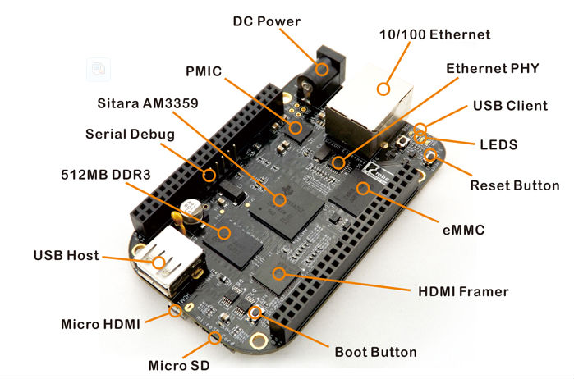

Interfacing of BBB with computer:

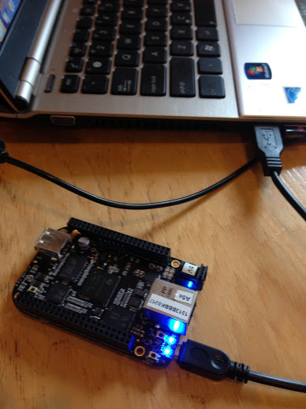

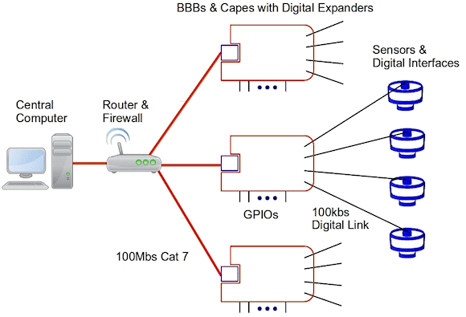

- Review Questionnaire:
1) What are the various components present on BBB REV C?
2) What are the functions of various components which are present on BBB?
3) What is GPIO?
4) Why resisters are used ?
5)What are the functions of P8 and P9?

- Conclusion :
Thus, after successfully completing this assignment, you should be able to understand & implement a small application using BBB.

